Project Progress Report
Day 23

Project Title
EduTrack – Student Performance & Dropout Risk Predictor

Work Completed Today
- Enhanced the dashboard with a cleaner layout featuring student statistics, priority alerts, and quick action panels.
- Created a dedicated Student Register page displaying student records, attendance, grades, and risk status with search functionality.
- Improved the Student Details page by organizing academic records, enrollment information, teacher notes, and risk factor analysis into a structured layout.
- Implemented responsive sidebar navigation with a collapsible hamburger menu for mobile devices.
- Connected all pages through proper navigation links to provide a smooth user experience.
- Refined the overall UI by improving spacing, typography, colors, reusable components, and responsive layouts across the application.

Screenshots of Developed Pages
1. Login Page
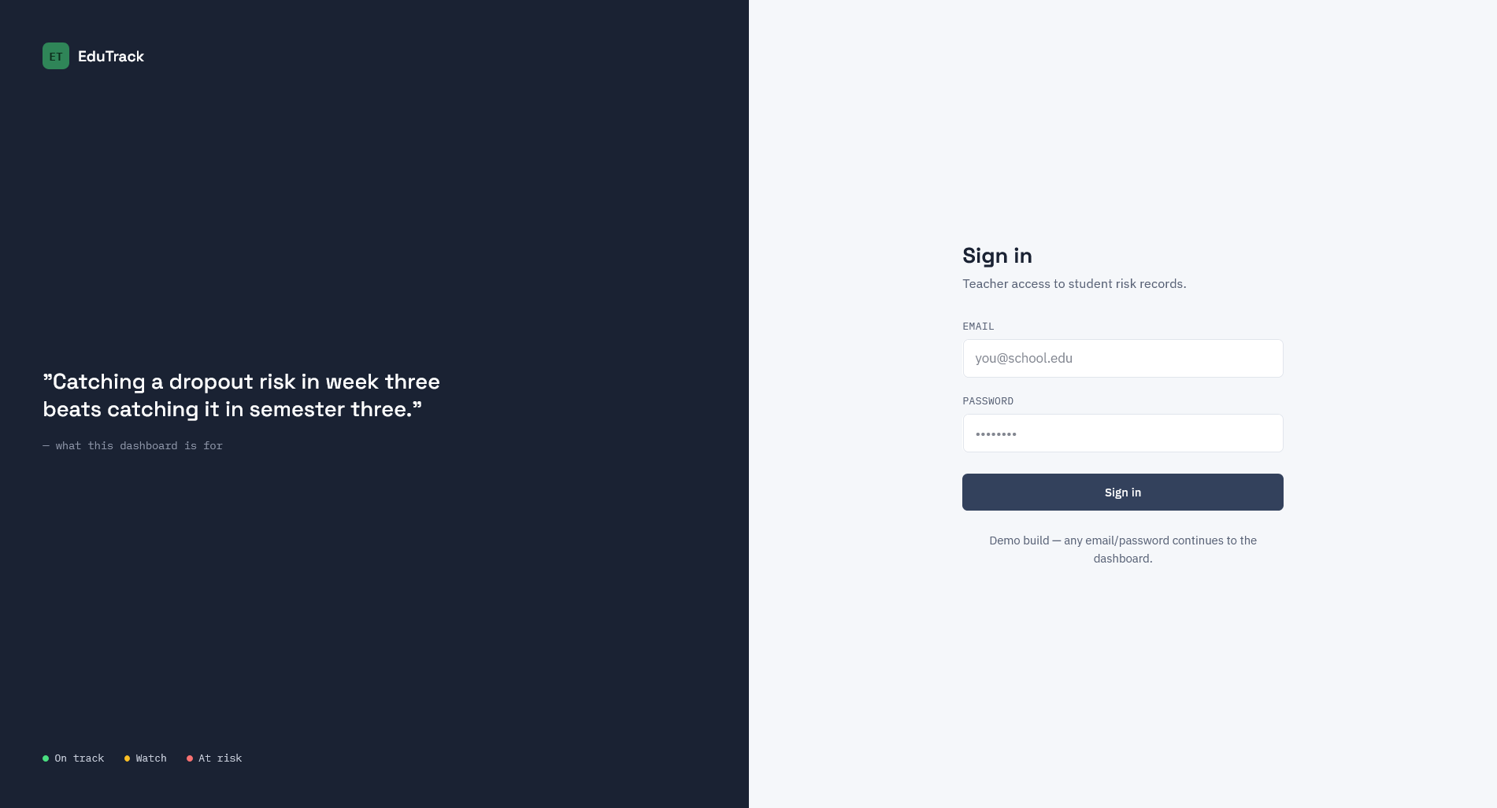

2. Dashboard
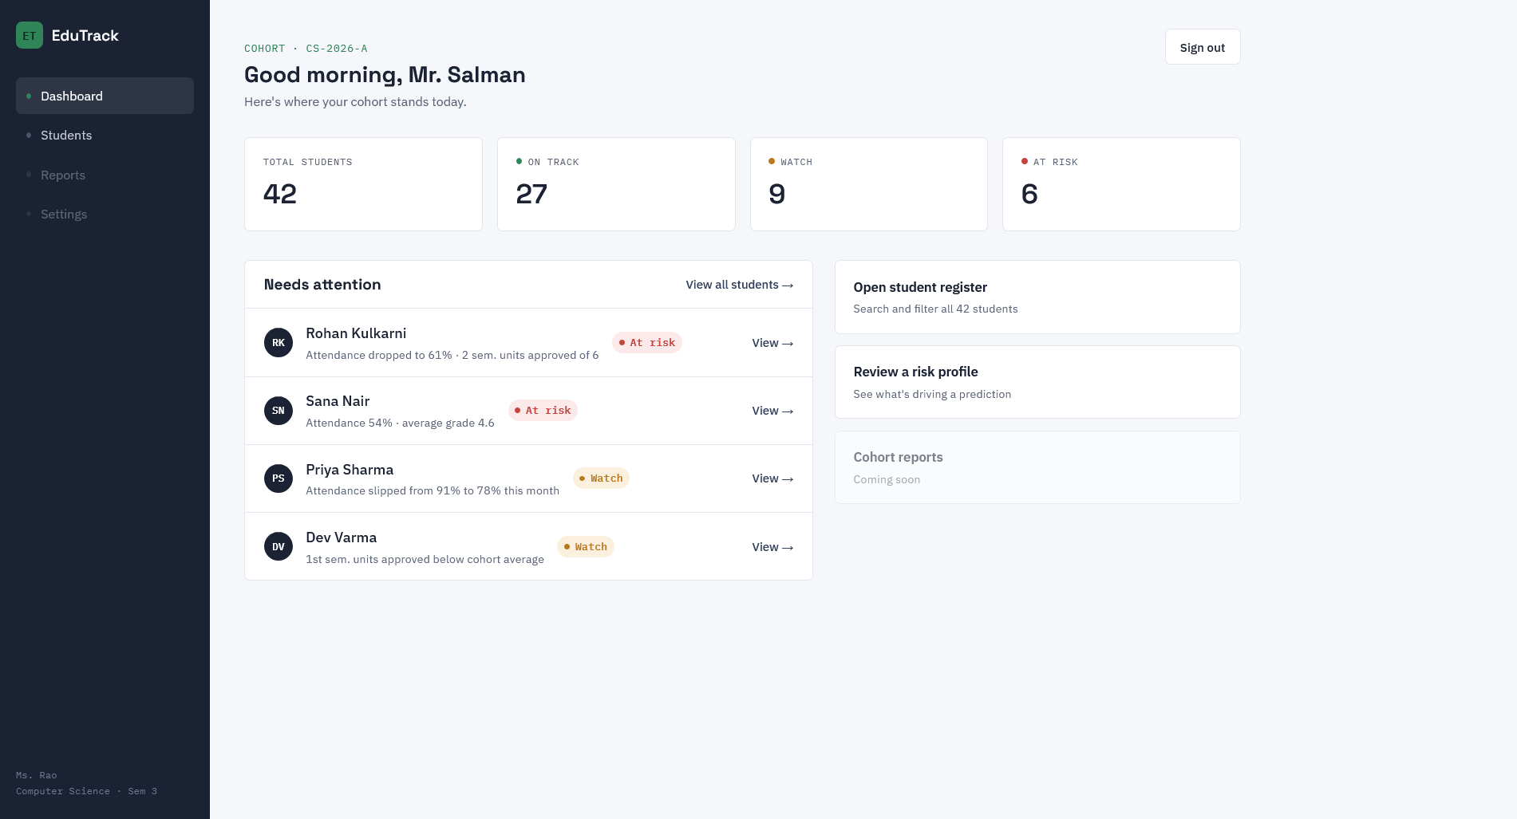

3. Student Register
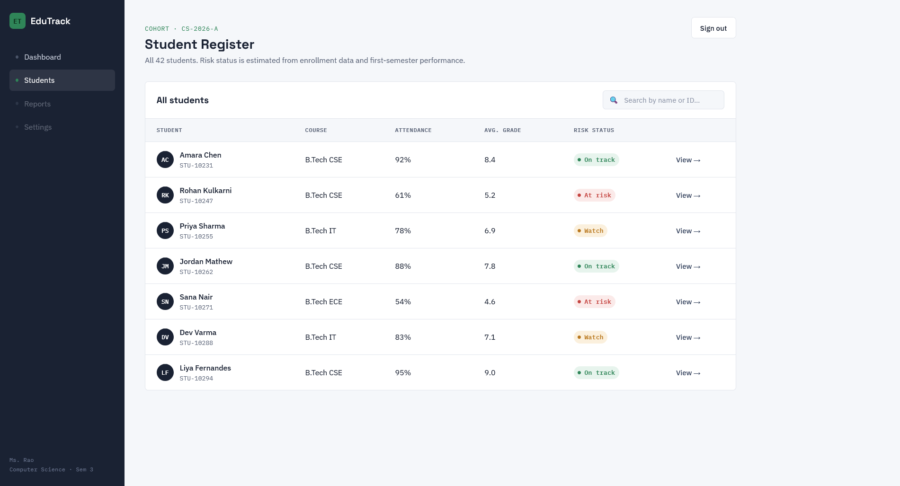

4. Student Details
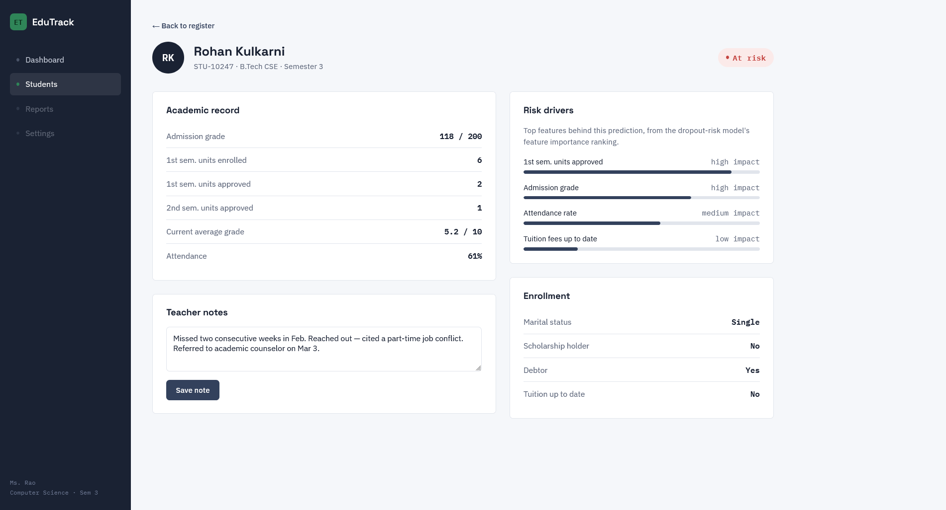

Brief Description of Improvements Made
The EduTrack frontend was significantly refined by improving the overall user interface and navigation between pages. A dedicated Student Register page was introduced, the dashboard was redesigned to highlight important student insights, and responsive navigation was implemented to support smaller screen sizes. Consistent styling, reusable components, improved spacing, and a professional design system were applied throughout the project, resulting in a cleaner and more user-friendly application.

Current Project Progress
✔ Login Page Completed
✔ Dashboard Completed
✔ Student Register Page Completed
✔ Student Details Page Completed
✔ Responsive Navigation Implemented
✔ Mobile-Friendly Layout Added
✔ Consistent UI Design Applied Across Pages
🚧 Reports and Settings Modules (Planned for Future Development)

